**Aster Graph Book**

You can use this page to record your idea.

To help you understand: the following attributes will be presented in abbreviation:

**Collab.** = Collaboration; **Phy. Man.** = Physical Manipulation;

**Inf. Fnd.** = Information Findability; **Inf. Org.** = Information Organization;

**Inf. Exp.** = Information Exploration; **Rng. Inp.** = Range of Content Input;

**Envmnt.** = Environment; **Tmpral.** = Temporality;

**Sptial.** = Spatiality; **Digtlz.** = Digitalization;

**Durabl.** = Durability; **Phy. Rcf.** = Physical Reconfigurability;

**Inf. Var.** = Information Variety; **Inf. Vol.** = Information Volume;

**Cost** = Cost; **Access.** = Accessibility; **Secrty.** = Security; **Prvicy.** = Privacy;

**Prsnal.** = Personalization; **Feedbk.** = Feedback;

**Aster Graph Sample**

Here, we demonstrate how to interpret our Aster plots. The Aster plot below was generated using arbitrary values. We included the following diagram purely for demonstration purposes.

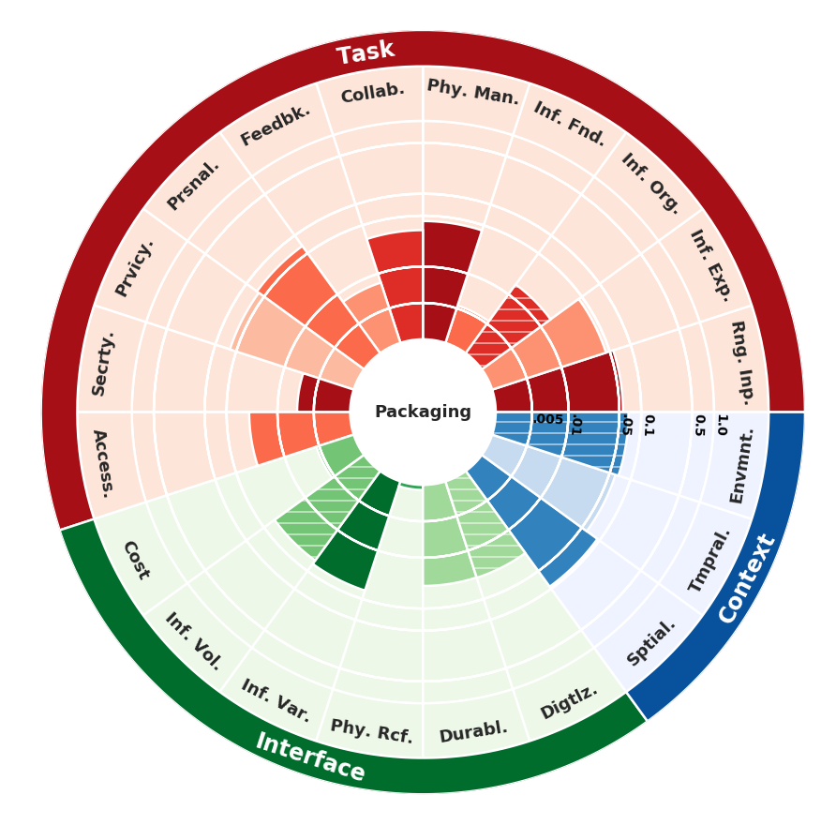

Bar Height: The height of each bar represents utility. This means that the **higher** the bar, the more users **preferred that product for that particular dimension**

Bar Color Shade: The color of each bar represents how important users think that dimension is for that particular product. **Darker** the bar, the **more important users perceive that attribute to be**

Line Texture: If the bar has stripes on it, it means that users **generally disagreed about the importance of that attribute** for a particular product

